The questions are answered in the reverse order meaning the last question(15) appears first and then the first question(13) and so on. For the second question source code and readme is updated separately. Screen shot is updated wherever applicable , in some places screen logs are pasted, and for some obvious cases only self-understanding of the command is written without any screenshot or logs.

15

* 1. a) In the system configuration of the VM, explain how changing the number of processors changes the behavior of your VM. Explain a scenario where you want to set this to the minimum, and a scenario where you want to set it to the maximum. Why is setting it to the maximum potentially a bad idea?

Ans: Changing the number of processor changes the performance of the vm. If we were to run some

load on the vm which is processor intensive such as encryption of entire hard disk when

disk is more or less full, this will be apparent. Also we could run many O(n2) algorithm

parallelly on the vm , more number of processors will certainly speed it up.

If we are using the Vm for workload which is not processor heavy such as editing

Or generating some document browsing web content, mostly text, then it is ok

To set the processor count to minimum.

If we are using the vm for testing performance of any heavily demanding application

such as gaming or data processing with large amount of data on which some algorithm

has to be run to find insight, then it is better to set it to maximum.

The problem with setting it maximum is that the host itself on which the virtualization

Software is running would suffer due to lack of processing resources.

* 1. b) In the system configuration of the VM, under the Acceleration Tab, explain the difference between the paravirtualization options: None, Legacy, Minimal, Hyper-V, and KVM. Explain which one would be best to use with Ubuntu Linux, and why.

Ans: None : specifying this option turns off exposing any paravirtualization interface to the guest OS.

Legacy : This option is for vms created with earlier versions of virtual box, while starting the vm

Some paravirtual interface would be selected in Virtual-box 5.0

Minimal: Announces the presence of a virtual environment to the guest OS.

Hyper-V: This option presents a Microsoft Hyper-V virtual environment or hypervisor interface to the

Guest OS. This virtual environment is recognized by windows7 and higher windows versions.

All kinds of guest Operating systems can be installed.

KVM : Presents a Linux KVM hypervisor interface which is recognized by Linux kernel starting from

2..6.25.

**This provider is recommended for Linux guest or Default can also be chosen as that would end**

**Up choosing the best option for the guest OS, in our case that is for Ubuntu this option should**

**Chosen.**

* 1. c) In storage devices when configuring the VM, there are multiple types of storage controllers: explain the difference between the IDE, SATA, and NVMe controller. Give an example for each type of storage controller of a scenario where you may want to use this type of controller.

IDE : Integrated device electronics is a standard using which data transfer happens between motherboard

To secondary memory that is hard disk. This protocol can also be used for CD-ROM and floppy and

Other kind of devices. It evolved though ATA1, ATA2 to ATA 5 standard while increasing data transfer

Rate and features or capability of the drive. Like in ATA1 , DMA (direct memory access) speed was 4.16

Megabyte but in ATA3 it changed to 16.67 megabyte. The cable used for IDE (ATA1)was a 44 pin

Connector which increased in ATA5 to 80 pin connector with DMA speed of 66 megabyte. This standard

Also got renamed to PATA once SATA came along in 2003.

SATA: Serial ATA started where IDE left off with initial version having speed of 1Gbps . It also got read off

Master / slave architecture of IDE. SATA got directly connected to the motherboard with connector

Which is 7 pin wide . 4 for data transfer and 3 grounds. SATA drives don't use jumpers.

Each drive connects directly to the motherboard. To set the primary drive, you can access the

settings from the computers BIOS (special software that runs when you start the computer).

* 1. NVMe: This is a protocol or standard which is developed ground up for SSD storage device. Connector is

PCIe express and performs very well with NUMA architecture. Though the SATA bus has evolved

to 16Gbps as of version 3.3, nearly all commercial implementations remain 6Gbps (roughly

550MBps after overhead). Even version 3.3 is far slower than what today’s SSD technology

is capable of, especially in RAID configurations. For the next step, it was decided to leverage a

much higher-bandwidth bus technology that was also already in place—PCI Express, or PCIe. PCIe

is the underlying data transport layer for graphics and other add-in cards. As of gen 3.x, it

offers multiple lanes (up to 16 in most PCs) that handle darn near 1GBps each (985MBps).

* 1. NVMe: For gaming. Cloud computing. Data center.
  2. SATA: For Gaming. Cloud computing and desktop computing. Data center.
  3. IDE: For desktop use.

* 1. d. In the network configuration of the VM, there are multiple types of network adapters: explain the difference between NAT, Bridged Adapter, Internal Network, and Host-only Network. Give an example for each type of network of a scenario where you may want to use this type of network.
* **Network Address Translation (NAT)**. If all you want is to browse the Web, download files, and view email inside the guest, then this default mode should be sufficient.
* **Bridged networking.** This is for more advanced networking needs, such as network simulations and running servers in a guest. When enabled, Oracle VM VirtualBox connects to one of your installed network cards and exchanges network packets directly, circumventing your host operating system's network stack.
* **Internal networking.** This can be used to create a different kind of software-based network which is visible to selected virtual machines, but not to applications running on the host or to the outside world.
* **Host-only networking.** This can be used to create a network containing the host and a set of virtual machines, without the need for the host's physical network interface. Instead, a virtual network interface, similar to a loopback interface, is created on the host, providing connectivity among virtual machines and the host.
  1. d)For the USB configuration of the VM, explain the difference between USB 1.1, 2.0, and 3.0 controllers.

The difference is in the speed of data transfer and power consumption. USB 1.0 devices can only

achieve a maximum speed of 12Mbps while 2.0 devices can theoretically achieve up to 40 times that

at 480Mbps. The real world speeds are lower for both standards since there are other factors that

can affect its total throughput.

USB 3.0 is the latest revision of the Universal Serial Bus standard released in 2008. This new

standard offers increased transfer rates up to 4.8Gbps, increased maximum bus power, improved

power management, and new connectors and cables that facilitate the higher transfer speeds

and additional power. Implementation of the technology began in 2009 initially with USB 3.0

adapters (PCIe and Express-Card) to allow installation of the new 3.0 ports into current computer

systems. Hubs followed allowing additional 3.0 expansion. PC computers and laptops have slowly

been implementing the new standard since 2010, but the new 3.0 ports are expected to be in the

majority of all new computers by 2012 when the popular manufacturers make it a standard.

Finally the last main difference is the available power and power management of the 3.0 products.

USB 2.0 provided up to 500 mA whereas USB 3.0 provides up to 900 mA, allowing power hungry

devices to now be bus powered. In addition the 3.0 technology allows better power efficiency with

less power for idle states or to remove power completely when not in use.

13.

a. ssh : this command is used to securely connect to a remote machine with a particular user. If the default shell of the user bash shell then you would land in a bash shell in the remote machine.

doing ssh from my host machine to the vm.

aboseblrmbp:~ arnab.bose$ ssh root@192.168.1.3

The authenticity of host '192.168.1.3 (192.168.1.3)' can't be established.

ECDSA key fingerprint is SHA256:jYeIb9MCWH+CCKNpKTbgL7/qDefXk5DRgbP/oWt8U5Q.

Are you sure you want to continue connecting (yes/no)? yes

Warning: Permanently added '192.168.1.3' (ECDSA) to the list of known hosts.

root@192.168.1.3's password:

Welcome to Ubuntu 18.04.1 LTS (GNU/Linux 4.15.0-45-generic x86_64)

* Documentation: https://help.ubuntu.com

* Management: https://landscape.canonical.com

* Support: https://ubuntu.com/advantage

* Canonical Livepatch is available for installation.

- Reduce system reboots and improve kernel security. Activate at:

https://ubuntu.com/livepatch

0 packages can be updated.

0 updates are security updates.

Last login: Mon Feb 4 00:38:26 2019 from 192.168.1.4

root@arnab-VirtualBox1:~#

root@arnab-VirtualBox1:~#

root@arnab-VirtualBox1:~# hostname

arnab-VirtualBox1

root@arnab-VirtualBox1:~# ifconfig -a

enp0s3: flags=4163<UP,BROADCAST,RUNNING,MULTICAST> mtu 1500

inet 192.168.1.3 netmask 255.255.255.0 broadcast 192.168.1.255

inet6 fe80::6906:4aa1:2c3e:1fe4 prefixlen 64 scopeid 0x20<link>

ether 08:00:27:04:e8:73 txqueuelen 1000 (Ethernet)

RX packets 7595 bytes 3224714 (3.2 MB)

RX errors 0 dropped 0 overruns 0 frame 0

TX packets 3552 bytes 264408 (264.4 KB)

TX errors 0 dropped 0 overruns 0 carrier 0 collisions 0

lo: flags=73<UP,LOOPBACK,RUNNING> mtu 65536

inet 127.0.0.1 netmask 255.0.0.0

inet6 ::1 prefixlen 128 scopeid 0x10<host>

loop txqueuelen 1000 (Local Loopback)

RX packets 297 bytes 24812 (24.8 KB)

RX errors 0 dropped 0 overruns 0 frame 0

TX packets 297 bytes 24812 (24.8 KB)

TX errors 0 dropped 0 overruns 0 carrier 0 collisions 0

root@arnab-VirtualBox1:~#

b. ssh-keygen: For generating public and private key for your machine.

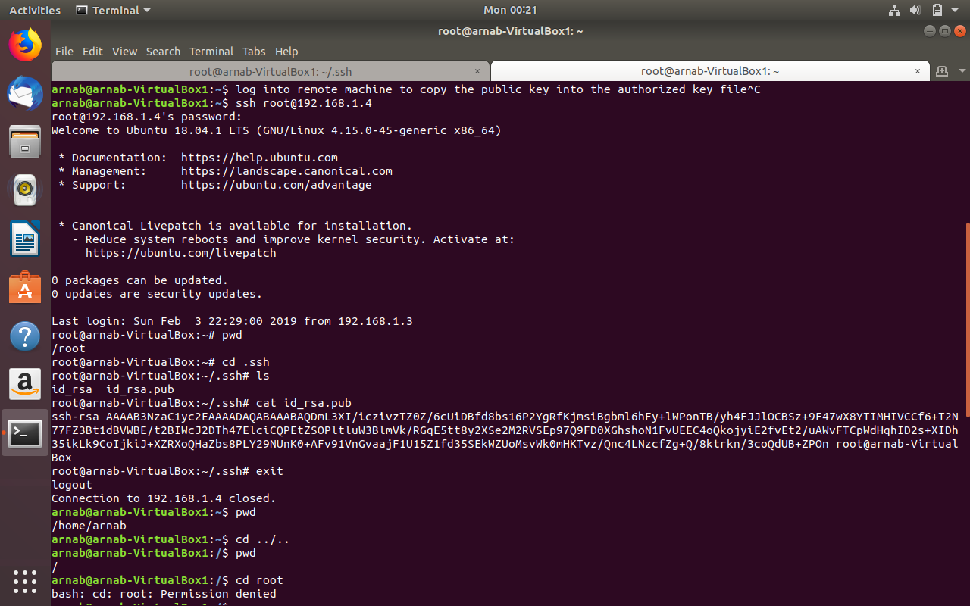

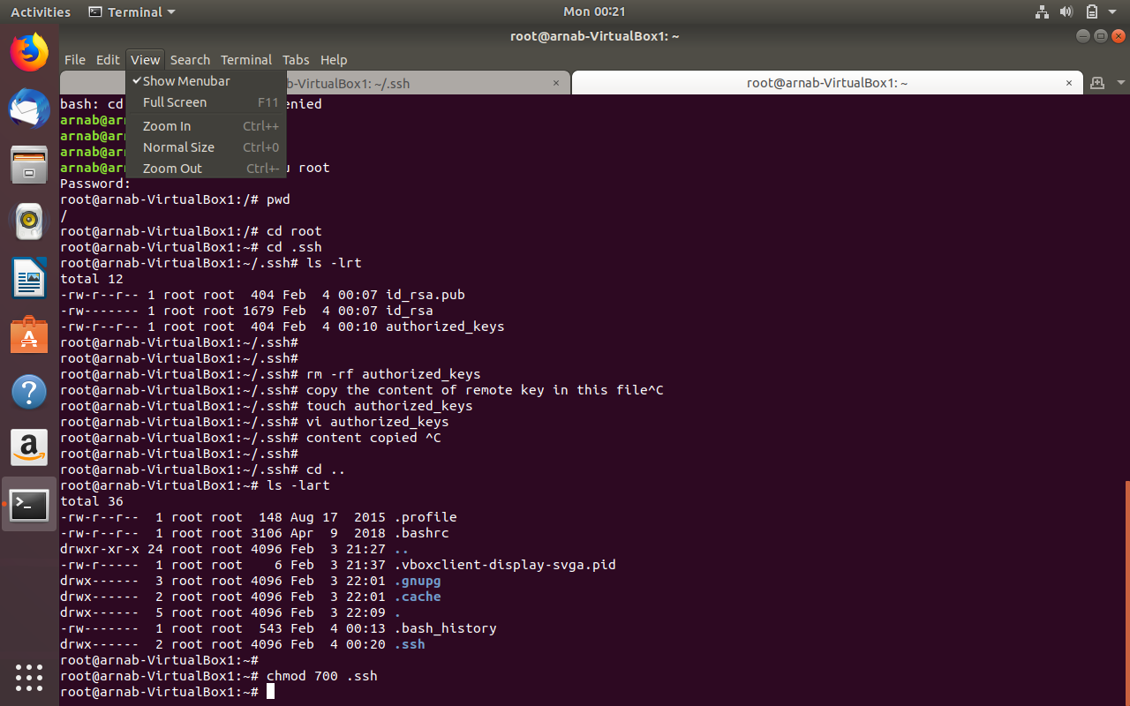

c. scp: when ssh is enabled this command is used to securely transfer files.

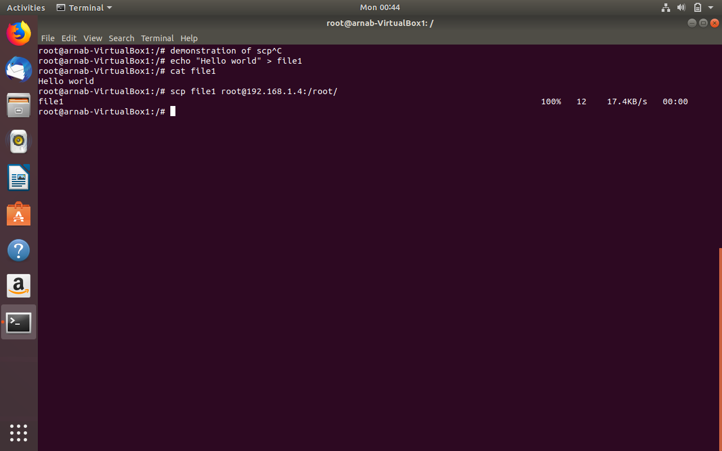

d. history: for looking at the command executed earlier.

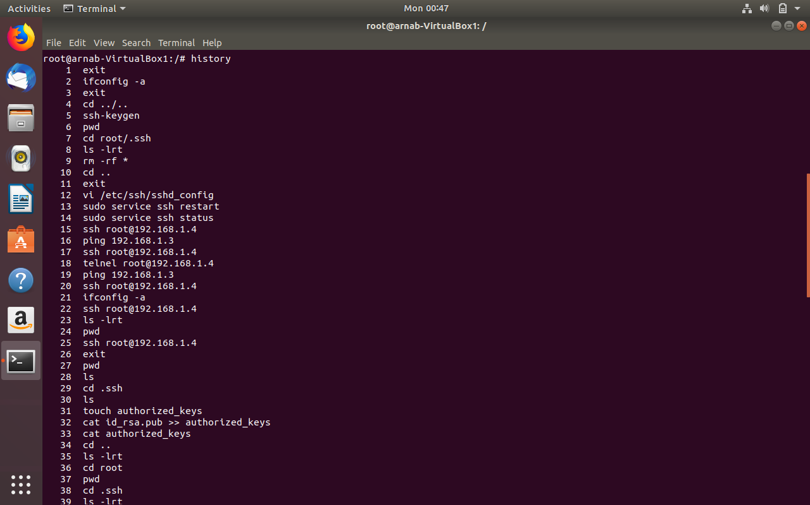

e. sudo : to execute command with super user permission.

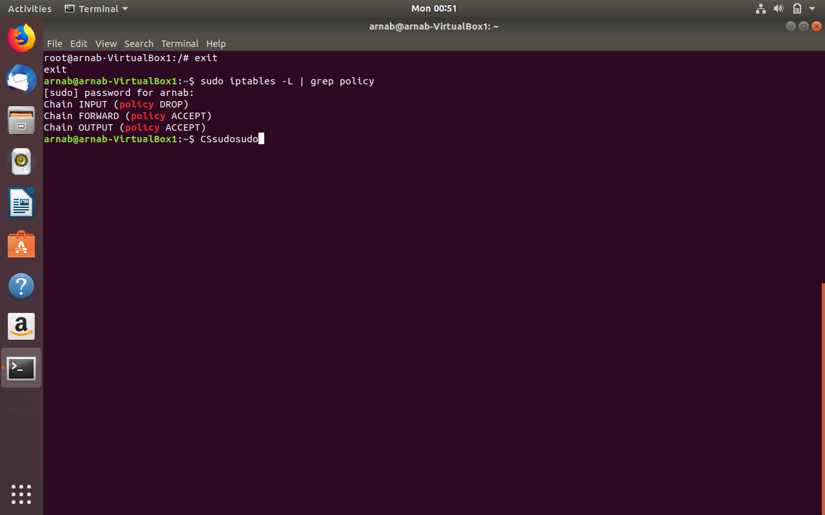

f. ip : For configuring network interface. Erstwhile ifconfig.

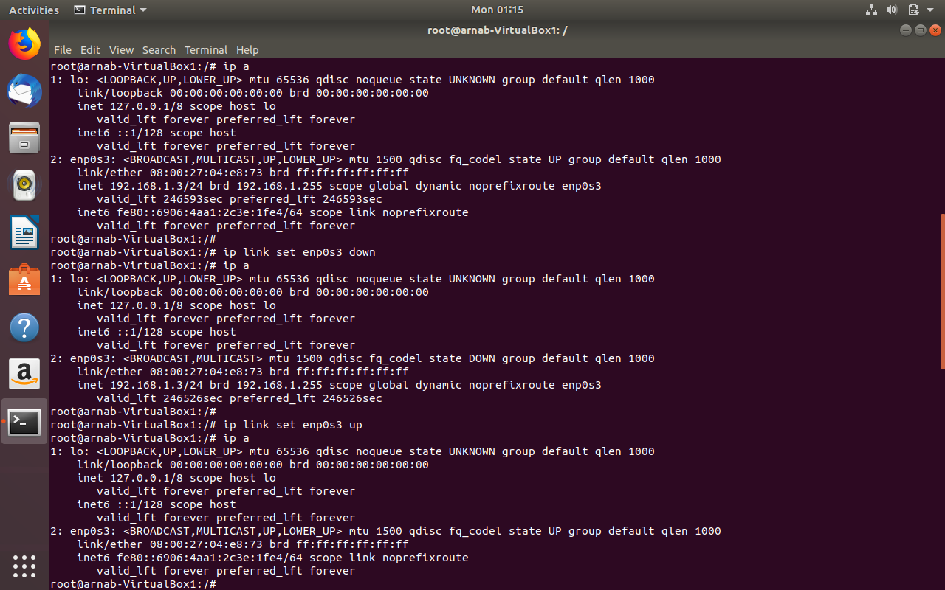

g. touch : For creating a file.

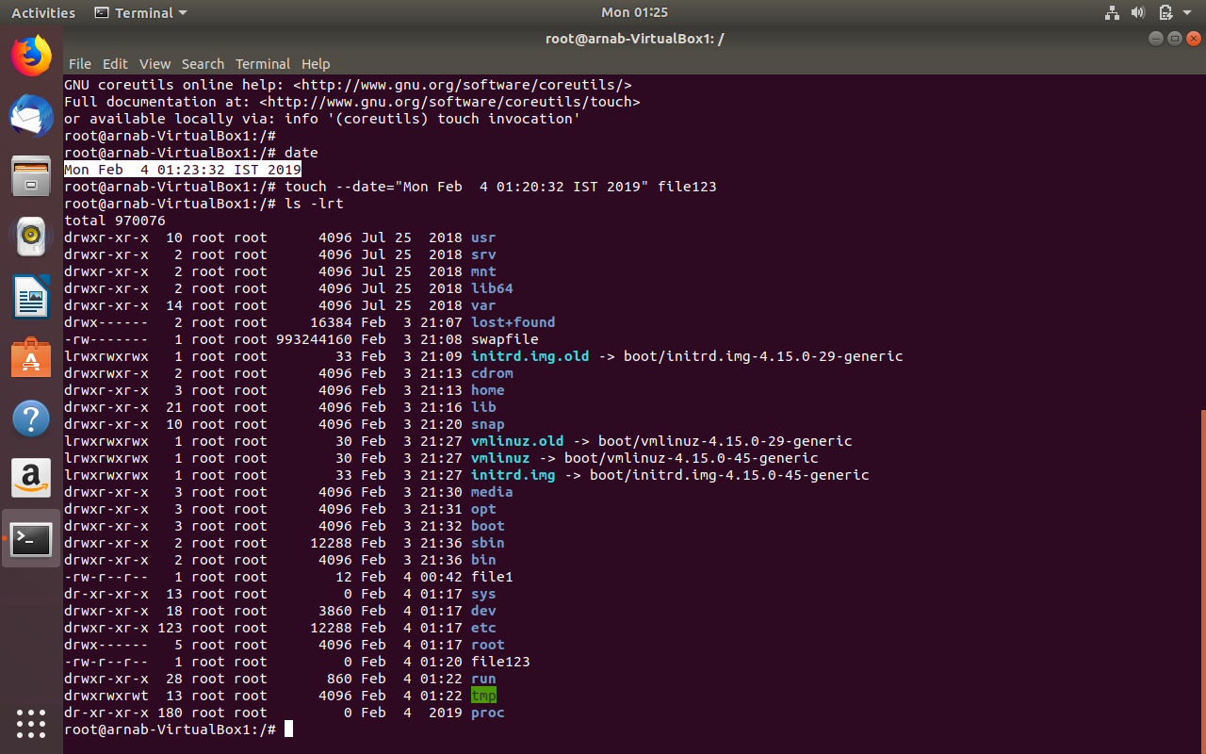

h. ls : For listing content of directory.

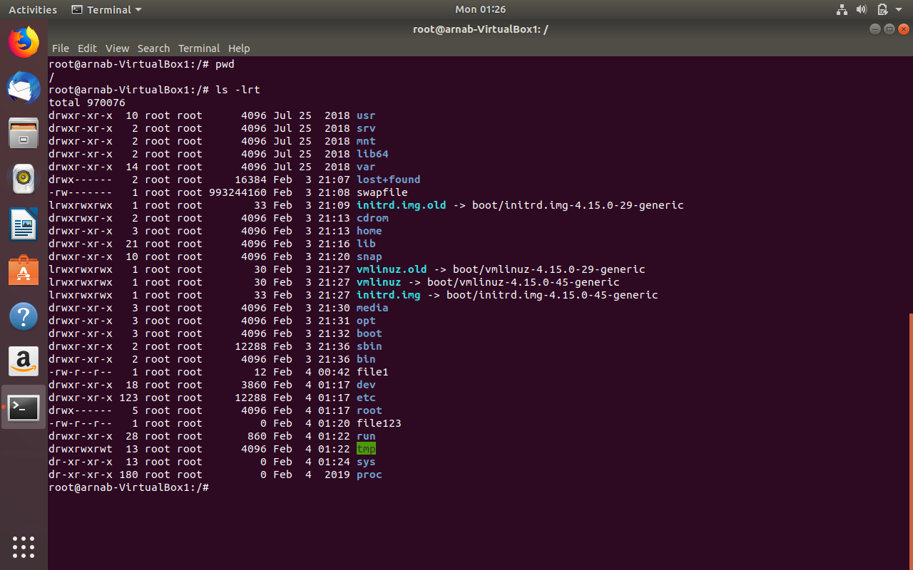

i.mkdir: For making directory.

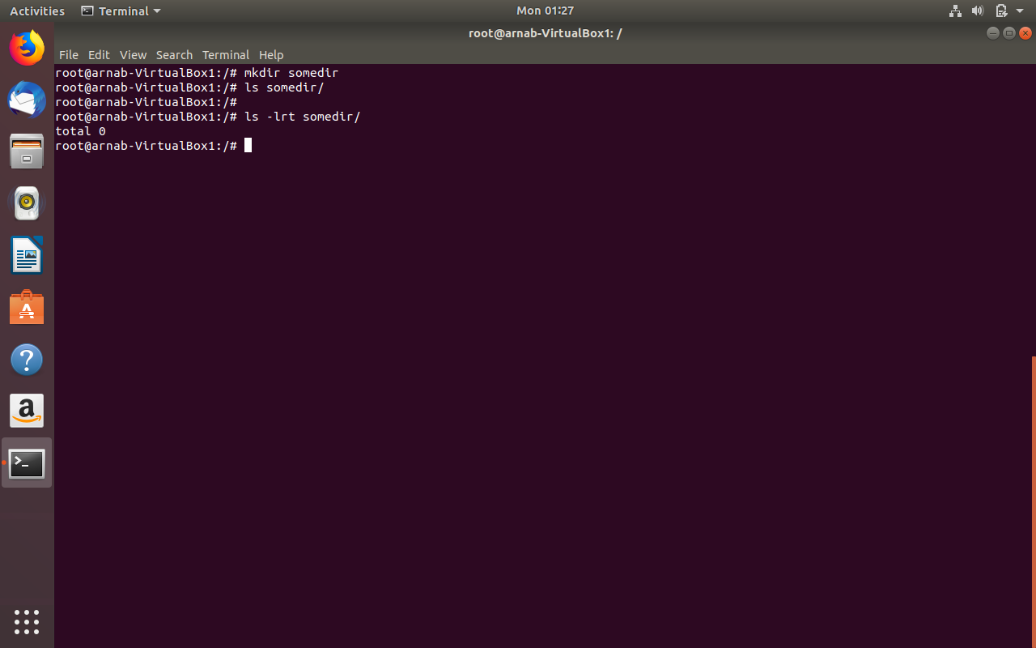

j. cd : for changing directory.

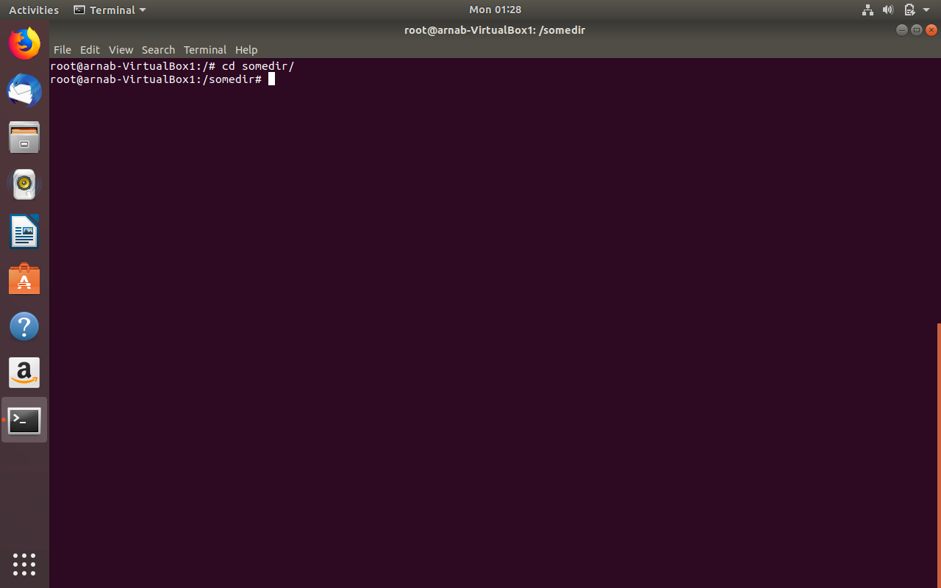

k. dd: For generating sequential data.

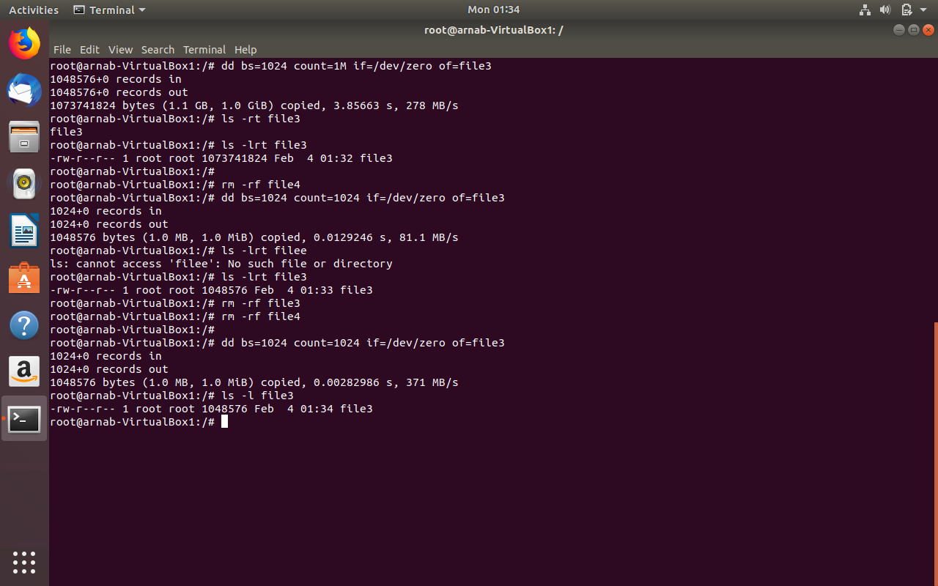

l. fdisk: for formatting and partitioning disk.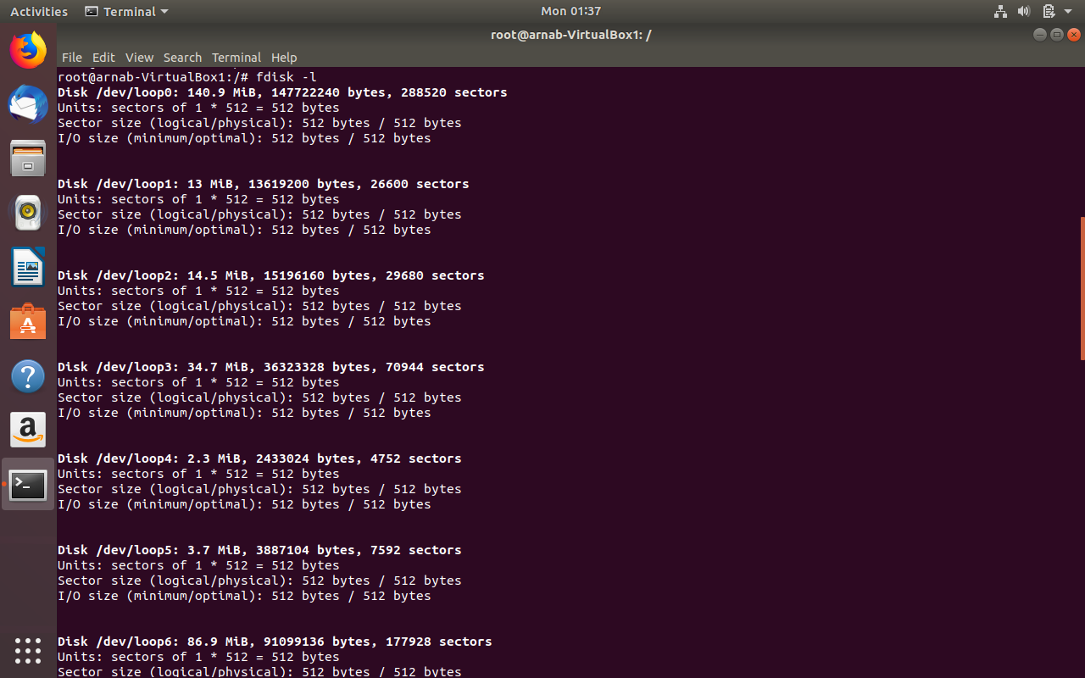

m. apt: command line package manager tool for searching ,managing, as well as querying about information

about packages. Example would be apt-get , apt-cache etc.

﻿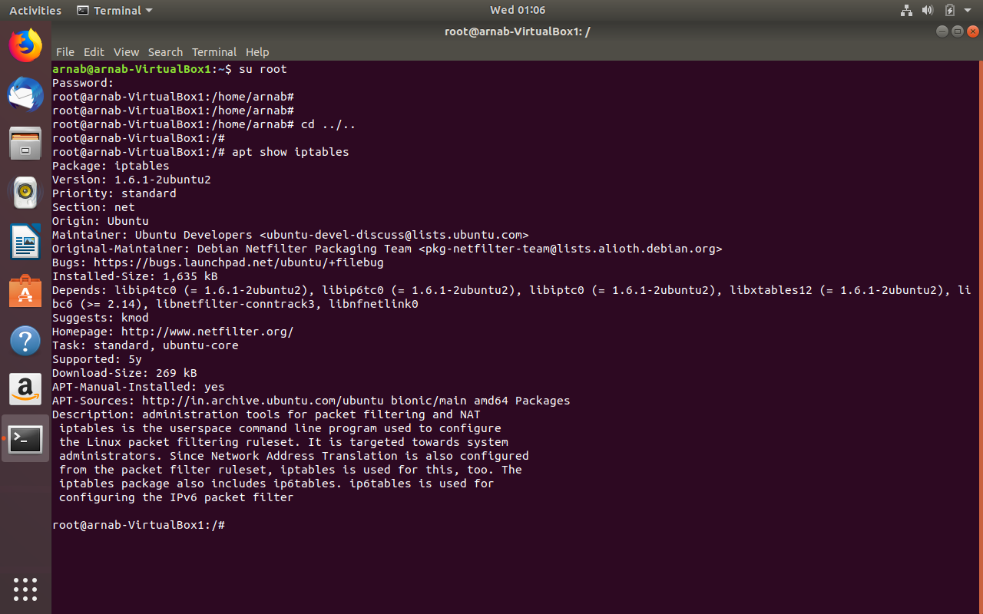

n. vi : vi is the command for vi editor, through which any user readable file can edited or even created.

Open a file for editing with “vi filename” command and then there are different mode through which

Editing can be done. One such mode is “insert” mode which can be entered with pressing “I” which

Will let you insert text into the file. To delete any already written content press “esc” if you are already

Insert mode then use key the “arrow” key to navigate up, down, left, right, when positioned on the

Character that you want delete press “x”. to delete a line press “dd” or position the cursor at the

Beginning line and then “shift-d” to delete the entire line. Certain portion of the text can be copied

By entering visual mode with “v” and then select the with arrow key and then y to yank or copy

The line and p to paste the line.

Search and replace can be done with vi with the following command. Hit esc first if you are in insert

Mode , and enter the command mode then use the command :s/something/something1/g.

To save and quite enter the command mode if you are in insert mode and then use the command

:wq!. To only save use :w!.

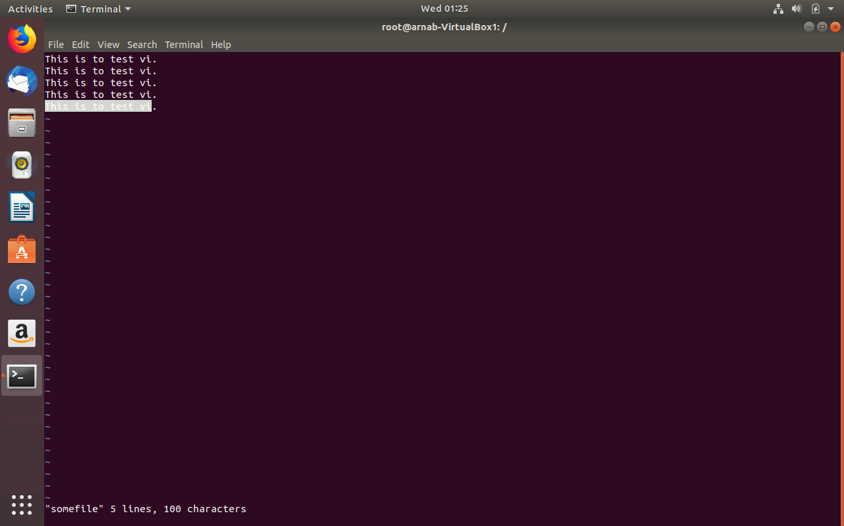

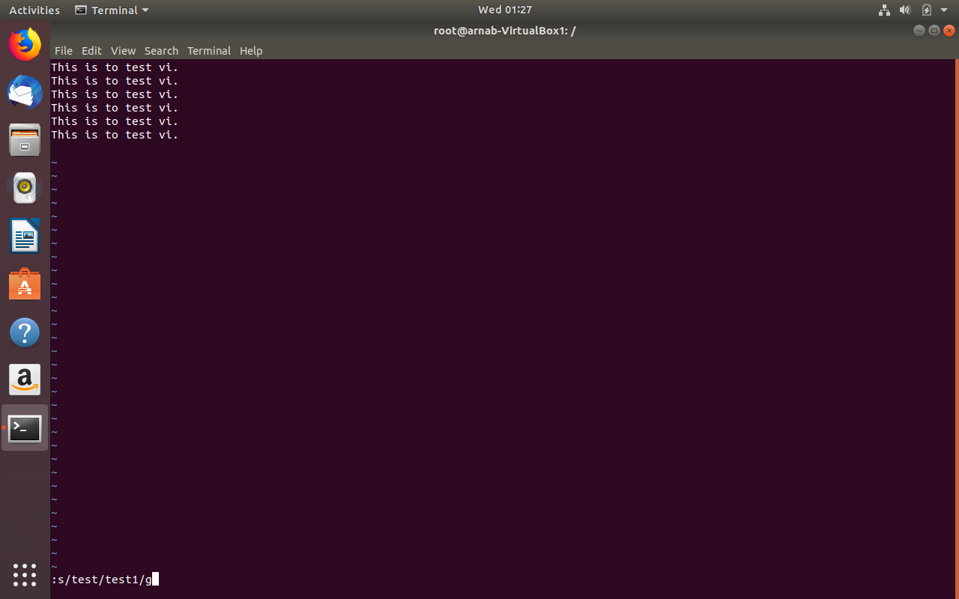

o. time : This is generally prepended with any command to measure how much time is being spent in the user

space and kernel pace by the command. This measures Wall time.

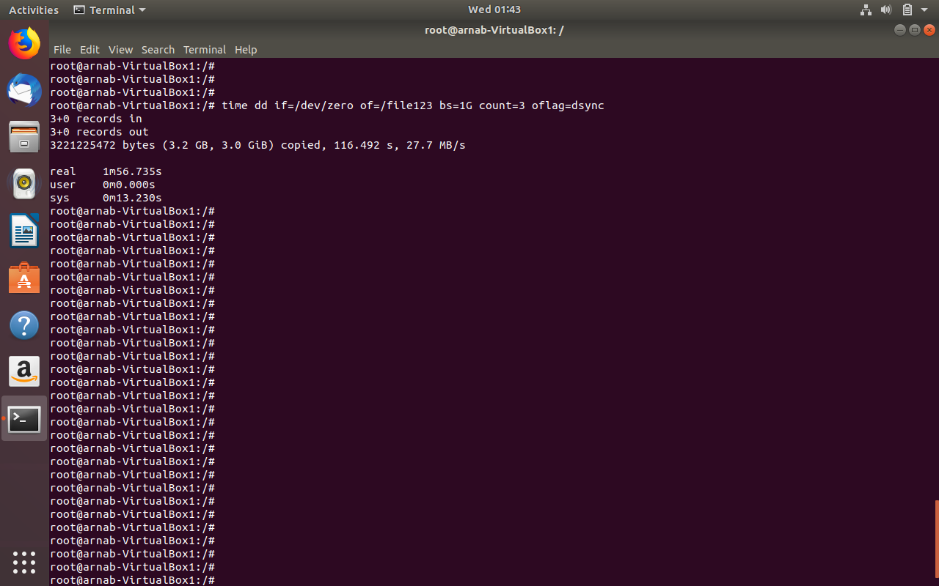

p. tar: This command is used to save many files together into a single tape or disk archive and can restore

an individual file from the archine

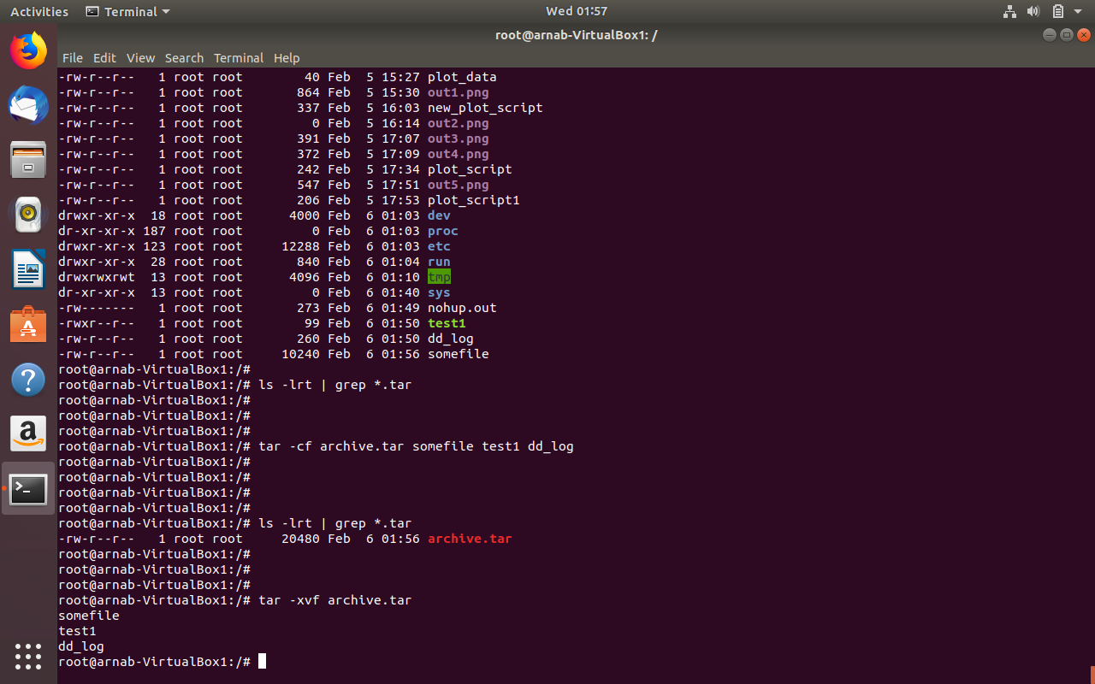

q. rm: This command is used to remove directory or file . with -rf that is recursive and force even the directory

with some content can be removed. There will no complain on the console, data would be removed

quietly.

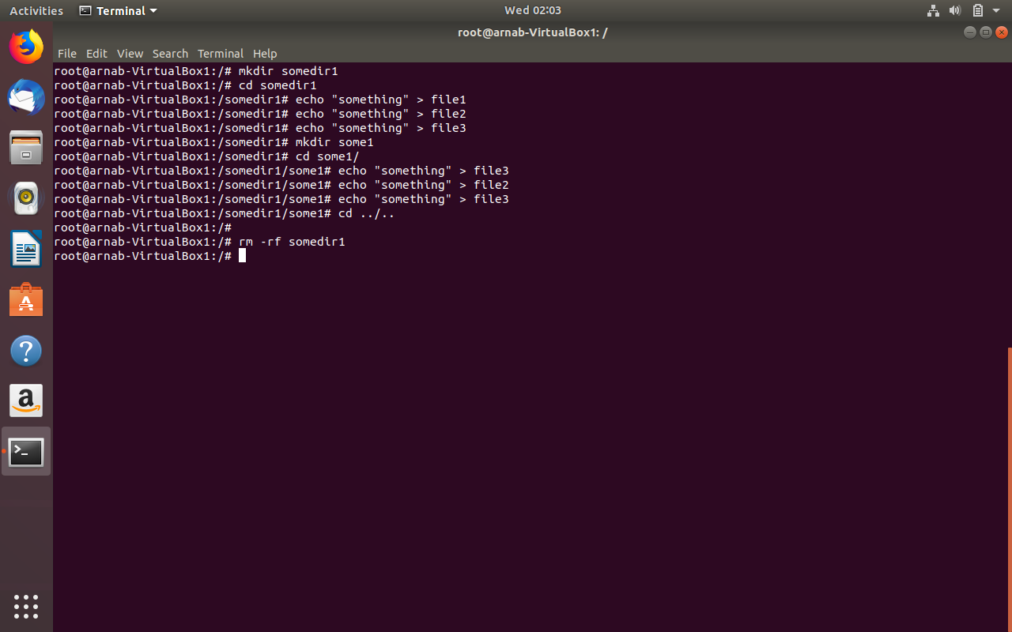

r. cat: For showing the content of the file on the console.

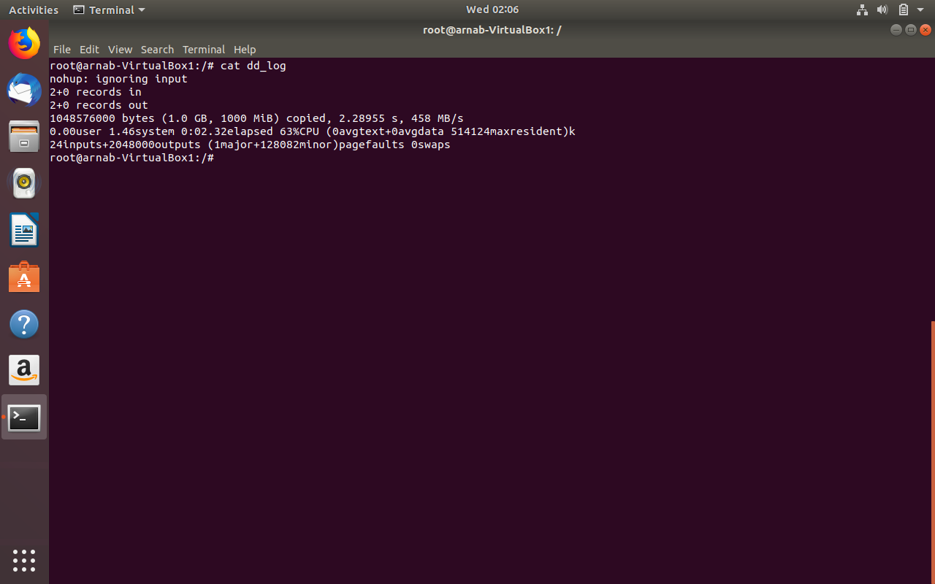

s. bash: bash command is used to run a shell script in bash shell. This is in general sh-compatible command

language interpreter.

t. more: This command used when content of a file a larger than a full screen. After one full screen of information use space to see the next screen of information.

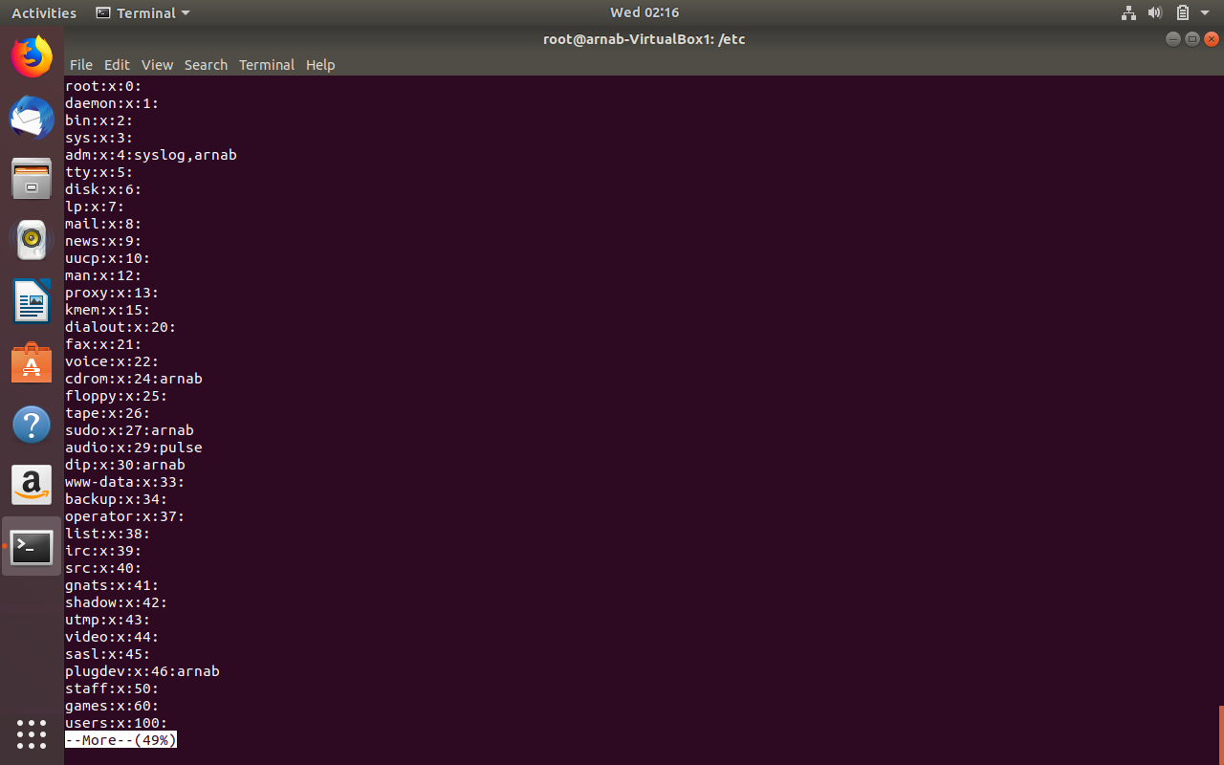

u. watch: watch runs command repeatedly displaying its output and errors. This helps you to watch the program output change over time.by default command is run every 2 seconds and watch will run until

interrupted. Come out of watch with ctrl+c.

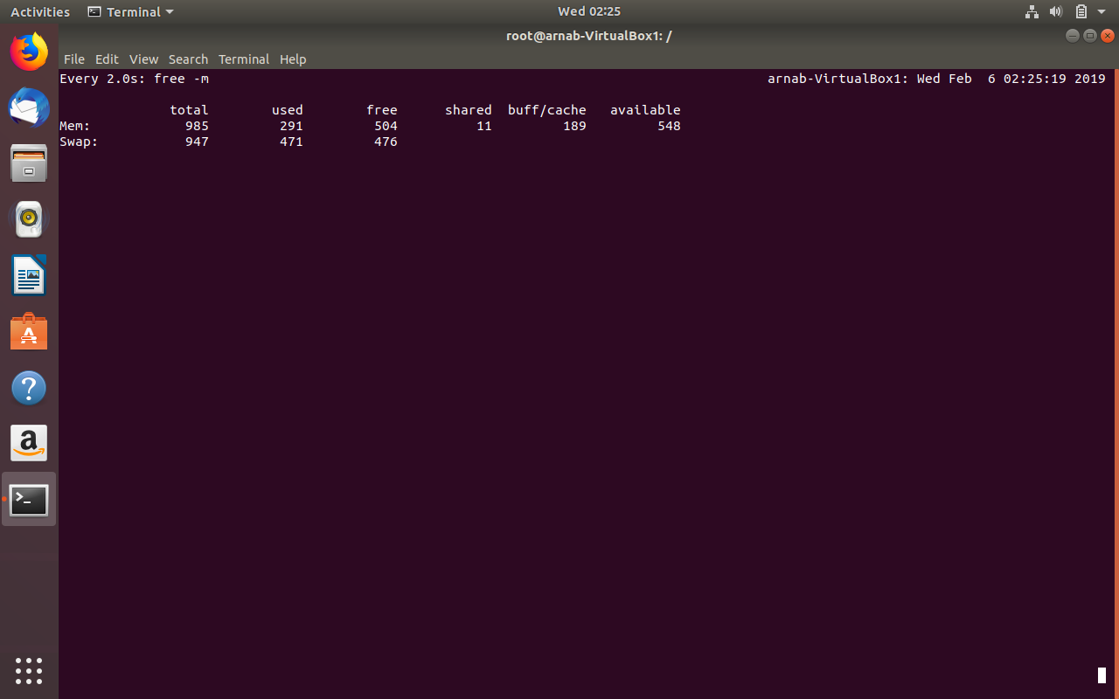

v. ps : ps command used to find out what process are running in the system currently, with -eaf tion.

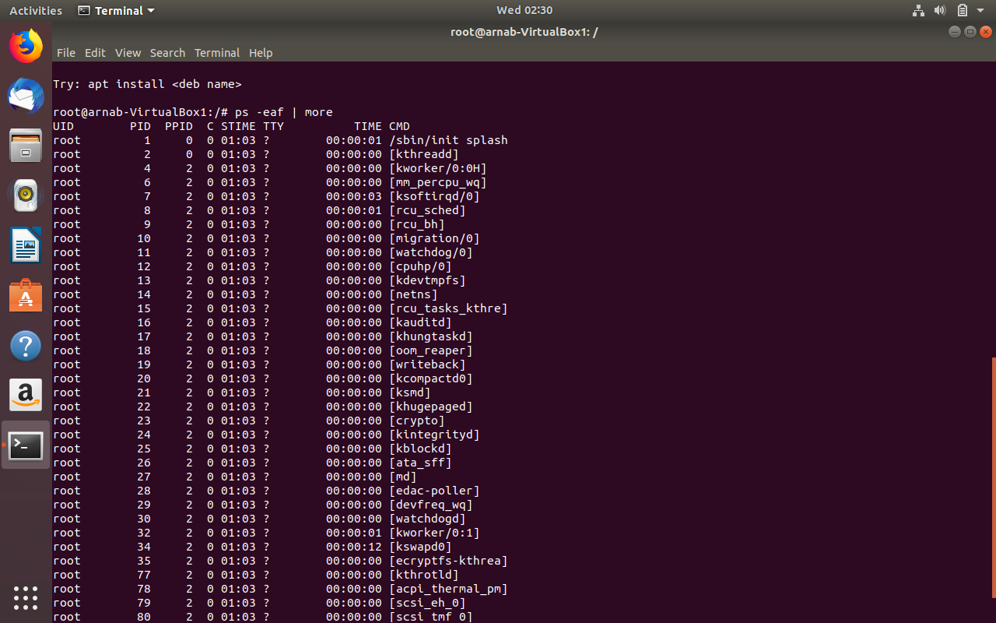

w. top: This command provide real time view of the linux system’s processes and threads.

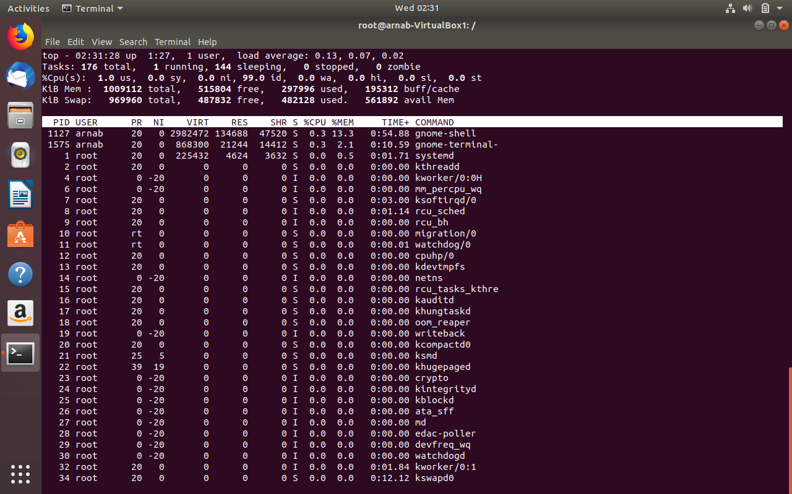

x. htop: text graph of linux machine’s memory and swap usages. Similar to top but more easier to use.

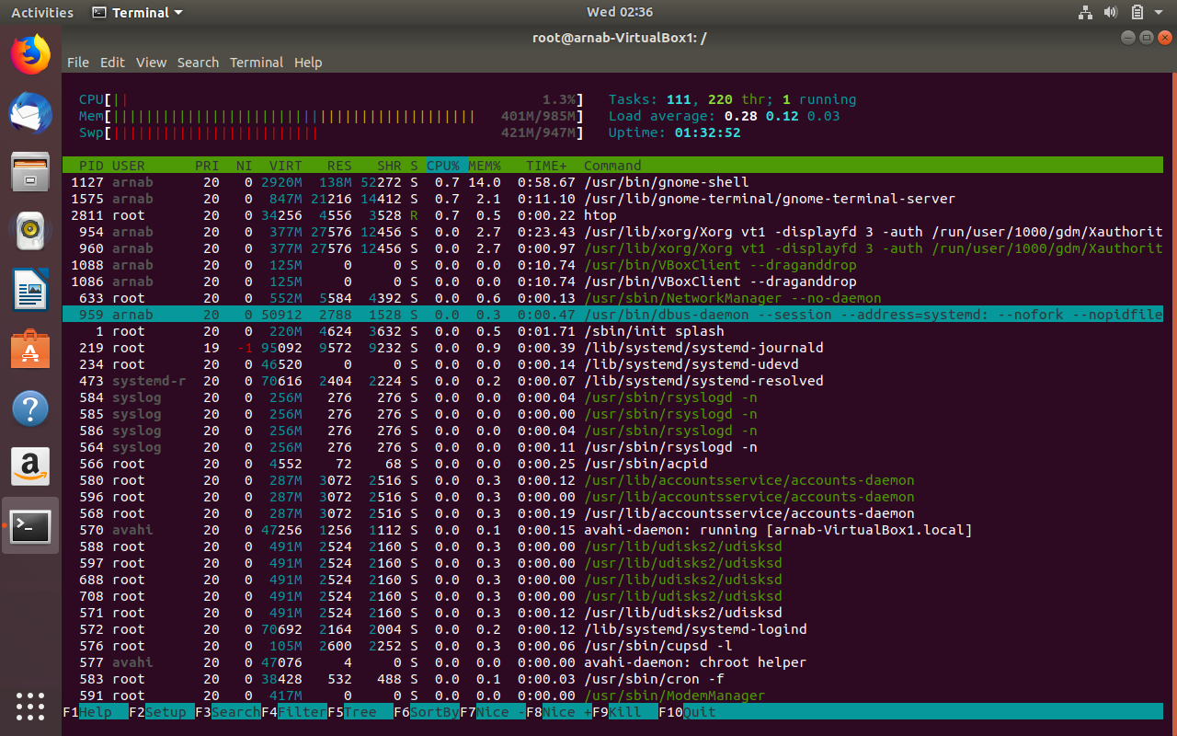

y.gcc: GNU c compiler.

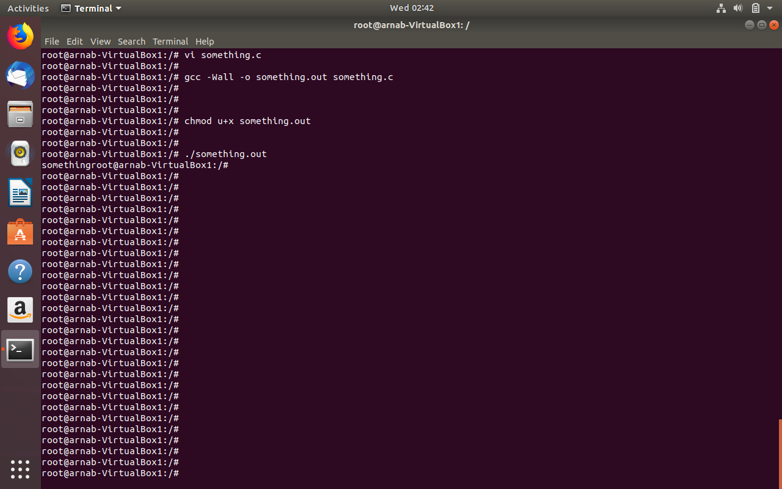

z. tail : this command is used to keep am watch on a log file which is continuously changing. Also to see last few lines of a file with tail -numlines filename syntax. For log file tail -f logfile.

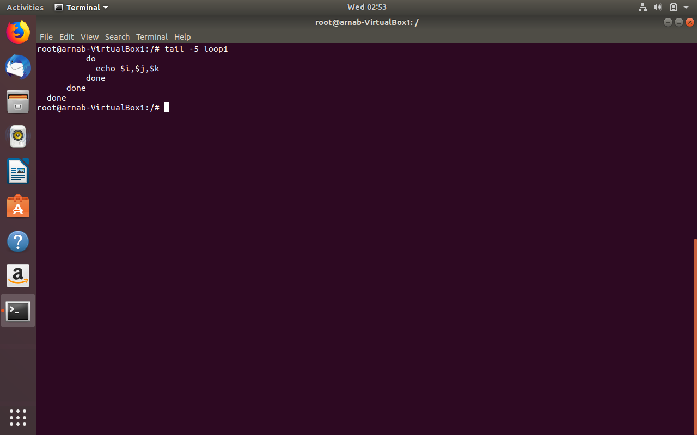

aa. grep: This command is used to find matching pattern inside file specially log files, with the syntax

grep -r pattern a recursive grep can be run inside a directory to find out any file with the pattern.

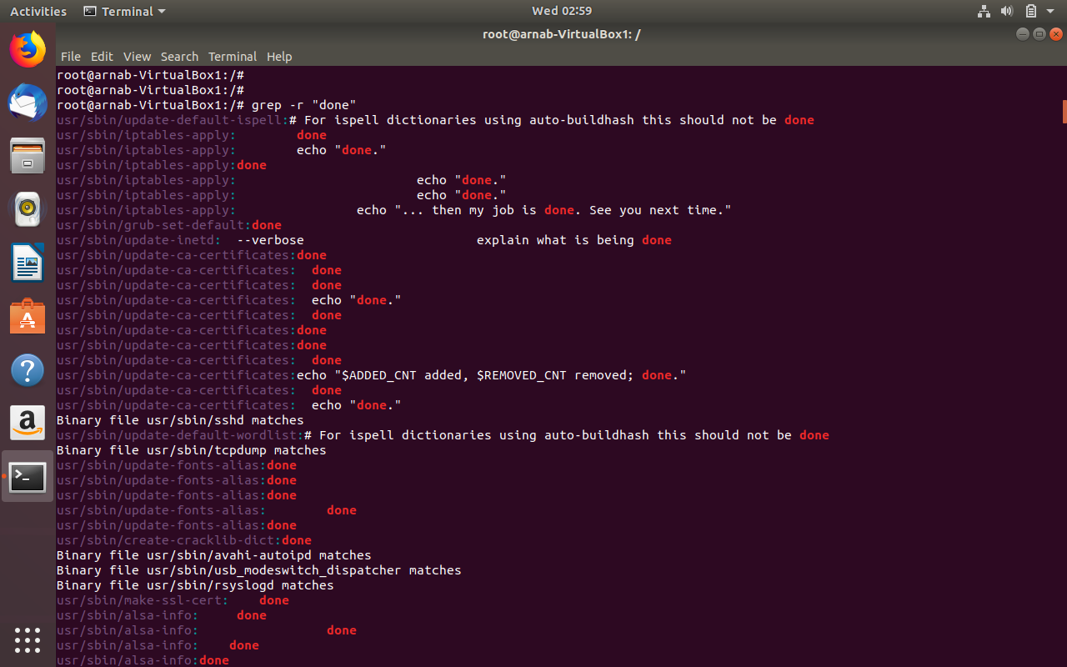

bb. kill: This command is to kill a process. Kill -9 is used to send a SIGKILL signal to the process to kill it

forcefully.

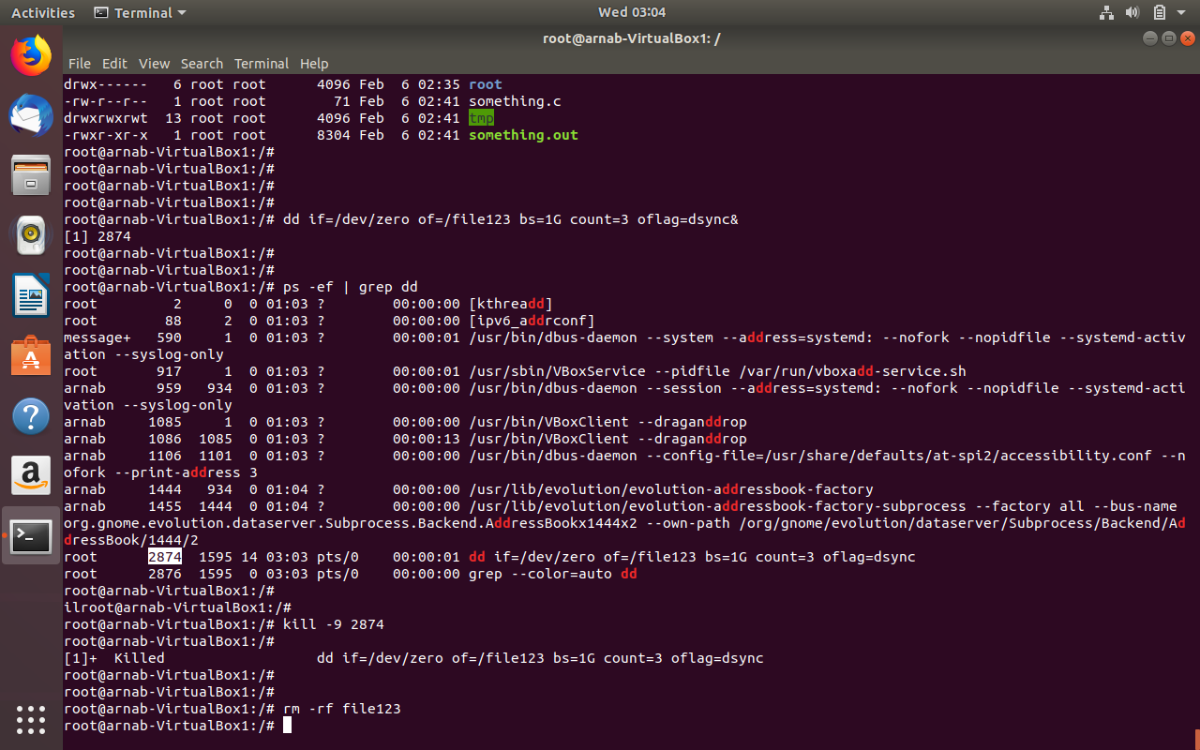

cc.killall: This commands kill the process by name . if no signal is specified then SIGTERM is used.

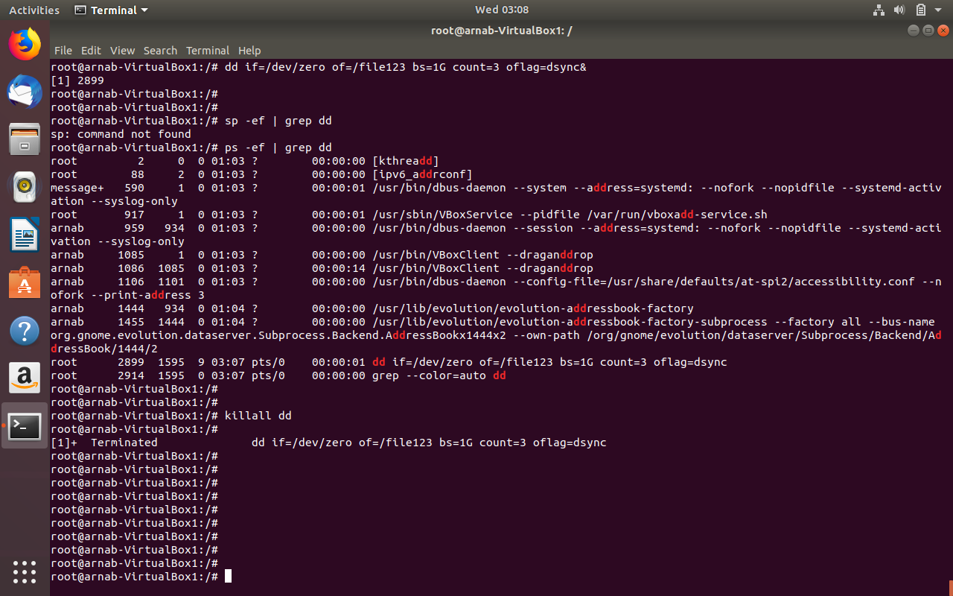

dd. du: disk usage is used to find out how much space a partition (/dev/sda) a file or directory is taking

on the disk.

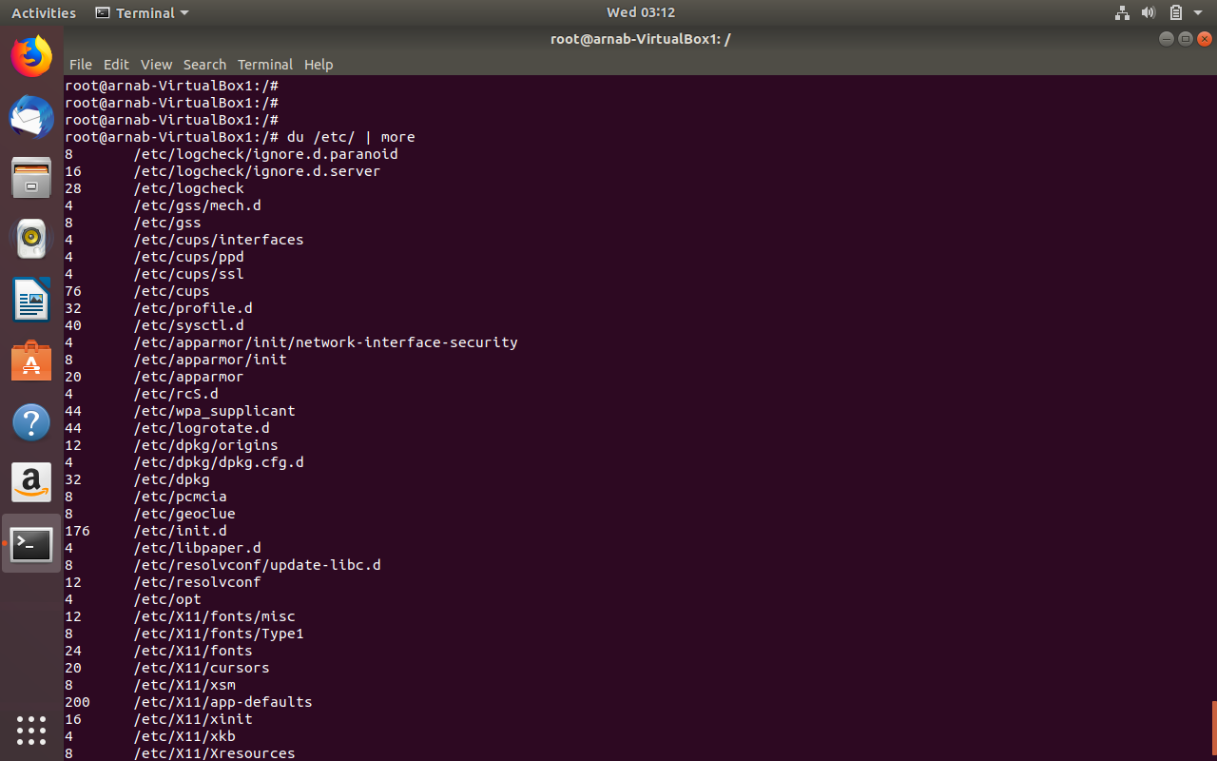

ee. df: This command is to find out which slice of the disk is mounted on which directory in the machine.

Also if there is any tmp filesystem or swap filesystem, all of them can be seen with df -kh command.

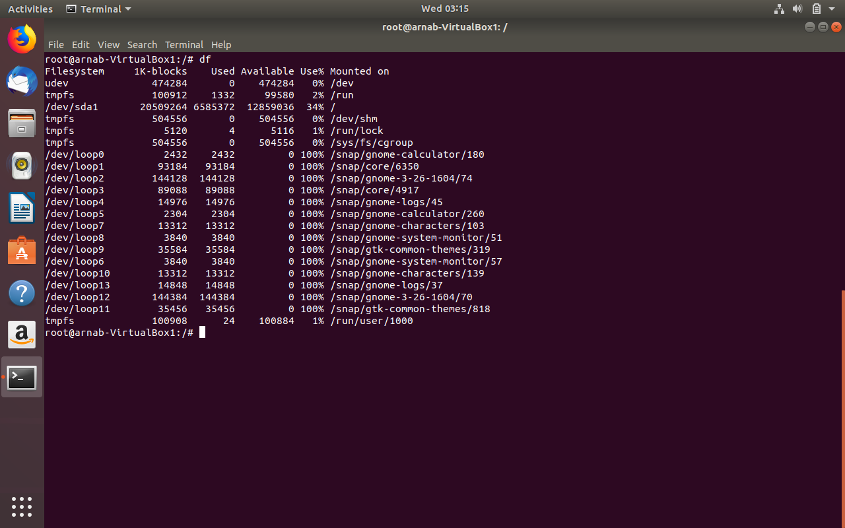

ff. screen: Screen is a full-screen software program that can be used to multiplexes a physical console between several processes (typically interactive shells). It offers a user to open several separate terminal instances inside a one single terminal window manager.

Install screen if it is not there in your machine then type command screen , it will start the screen session.

Then start a top command , this will be running in screen1 and then use ctrl + a +c to create another

Screen and htop in that and then you can switch between them with ctrl +a+ n.

To detach a screen ctrl + a + d this will drop you in your shell and you can reattach the screen with screen -r.

gg. vim: same as vi but with more capability to handle larger file.

hh. chmod: to Change mode bit of any object in linux . object such directory or file.

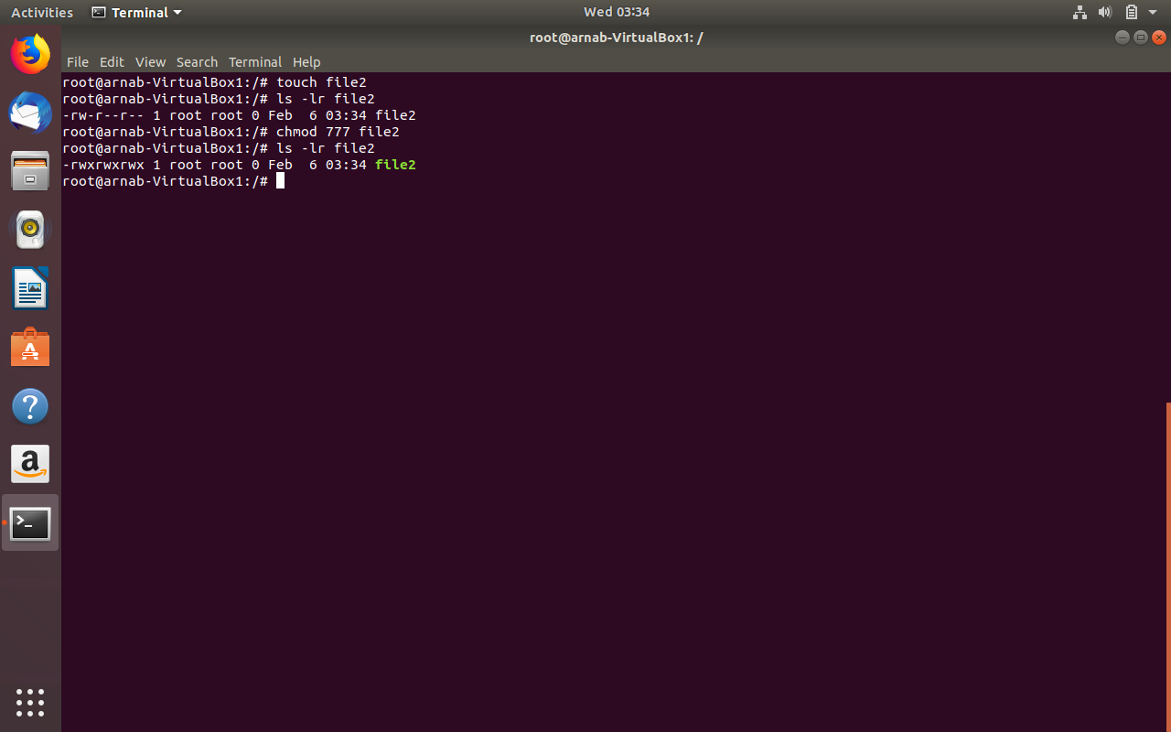

ii. chwon: to change ownership of any object such as directory of file.

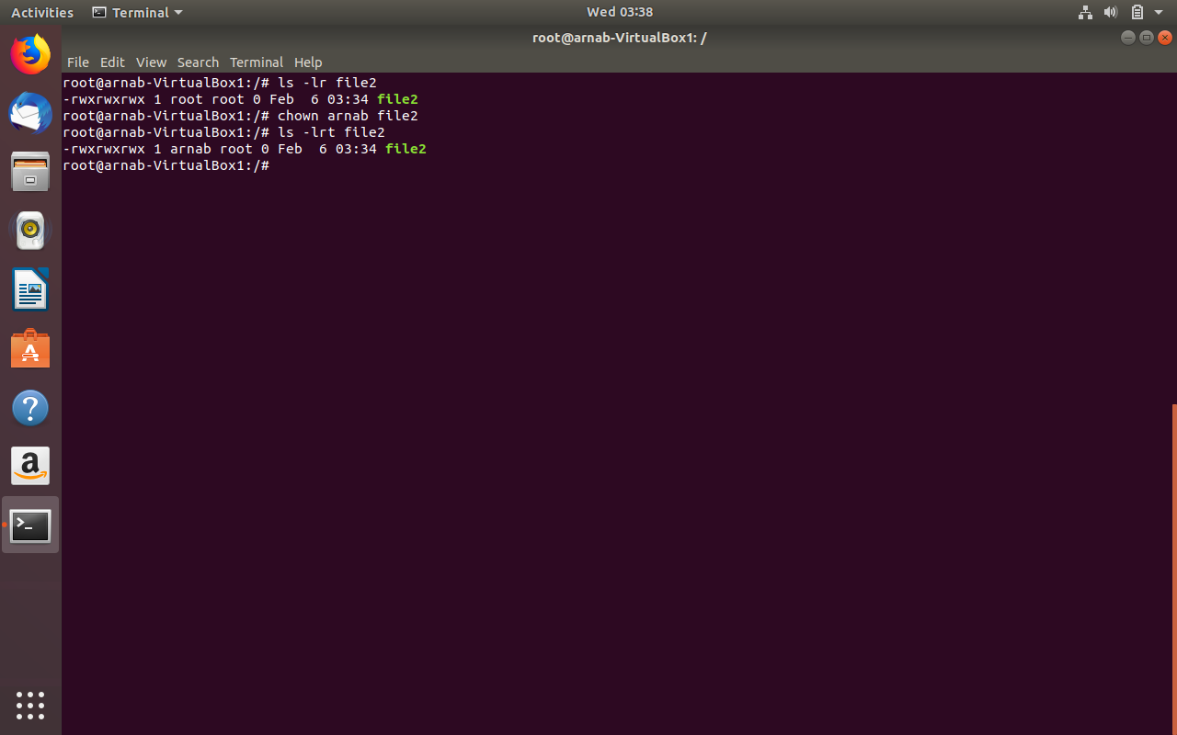

jj. useradd. To add a local user in the linux machine.

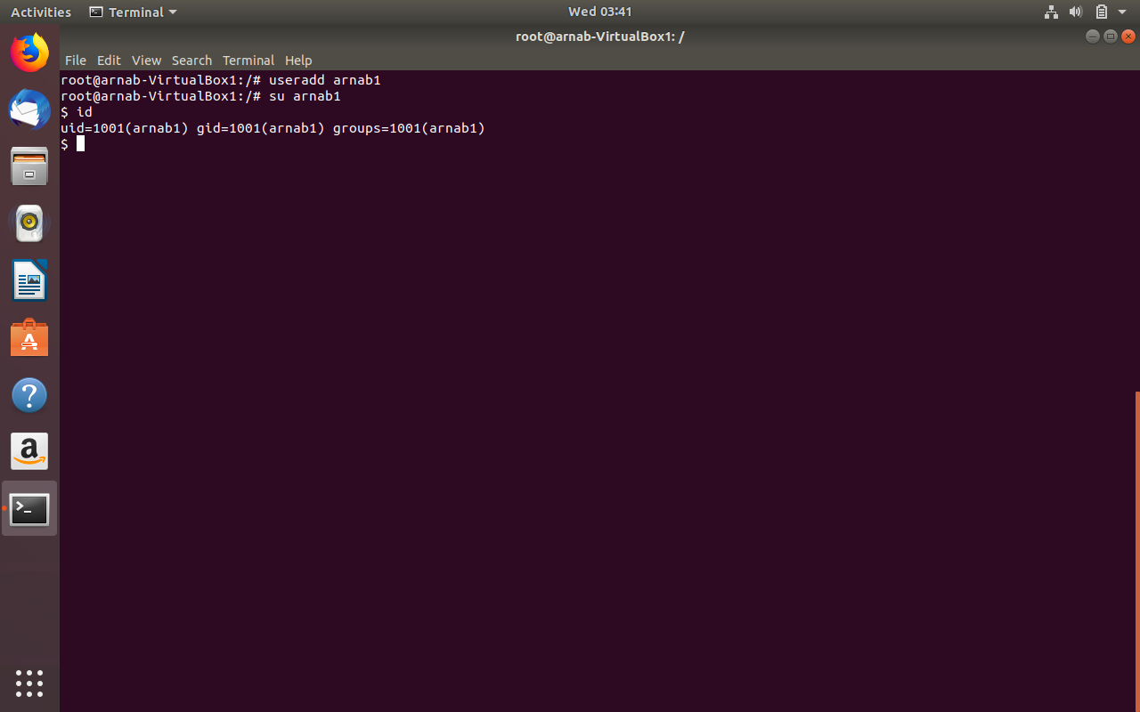

kk.mv: to move the some file or directory from source to destination folder.

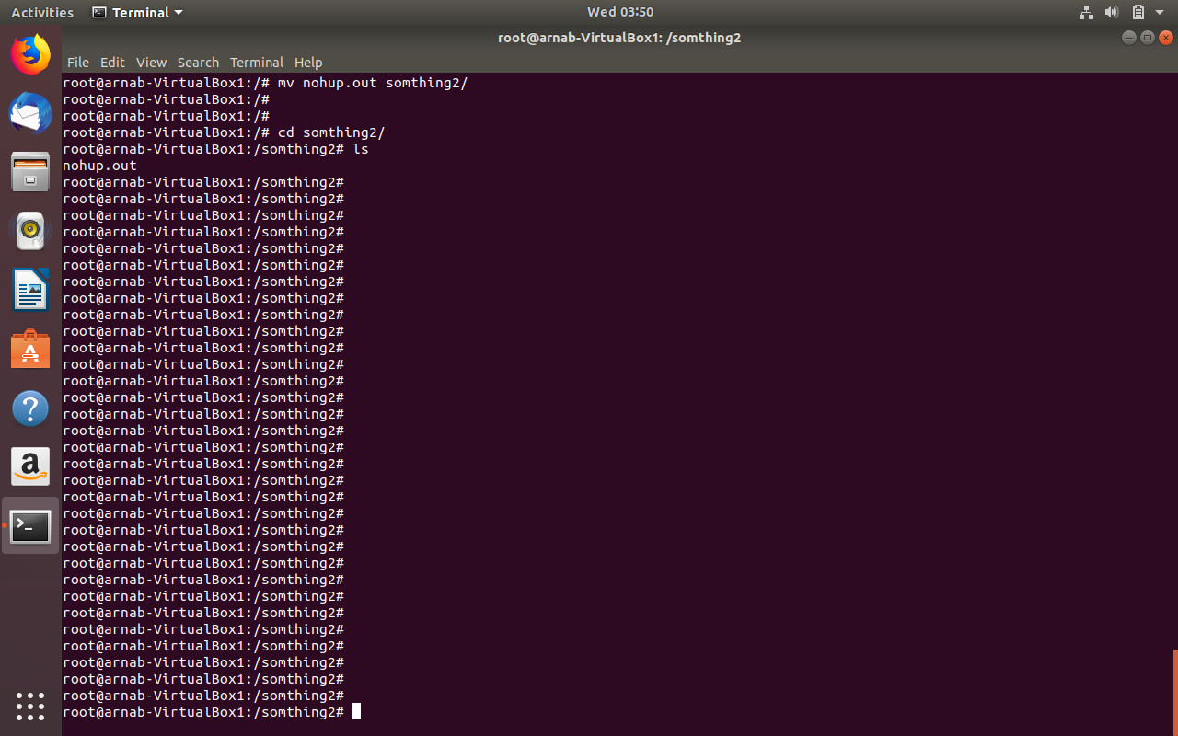

ll. man : man pages are for description and usages of any command. There are different section of man pages such as man(1) through man(8).

mm. locate: this command is similar to find command only this is little faster as this maintains some database

with bits and pieces of information about the files in the filesystem.

nn. find: This command is also used for finding files and pattern inside files. With the syntax

find ./ -name “*.py” | grep xargs “def”, this command will find all the python methods in all .py files

recursively from current directory down.

oo. sed: this command in UNIX is stands for stream editor and it can perform lot’s of function on file like, searching, find and replace, insertion or deletion. Though most common use of SED command in UNIX is for substitution or for find and replace. By using SED you can edit files even without opening it, which is much quicker way to find and replace something in file, than first opening that file in VI Editor and then changing it.

By default, the sed command replaces the first occurrence of the pattern in each line and it won’t replace the second, third…occurrence in the line.

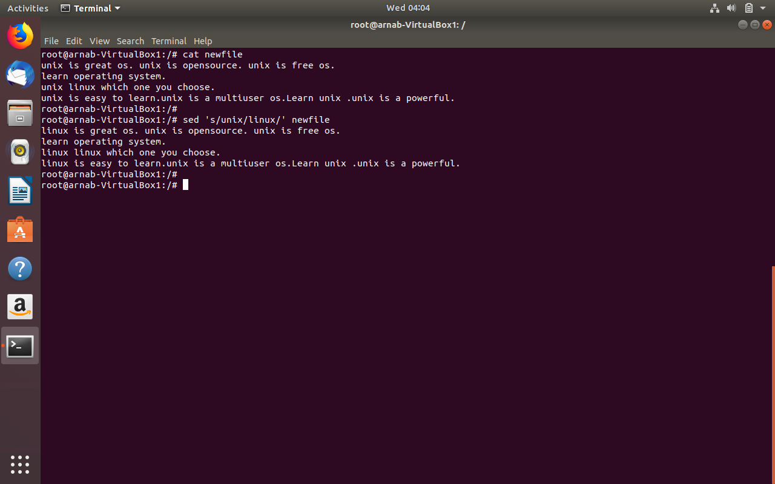

pp. awk: Awk is a scripting language used for manipulating data and generating reports.The awk command programming language requires no compiling, and allows the user to use variables, numeric functions, string functions, and logical operators.

Awk is a utility that enables a programmer to write tiny but effective programs in the form of statements that define text patterns that are to be searched for in each line of a document and the action that is to be taken when a match is found within a line. Awk is mostly used for pattern scanning and processing. It searches one or more files to see if they contain lines that matches with the specified patterns and then performs the associated actions.

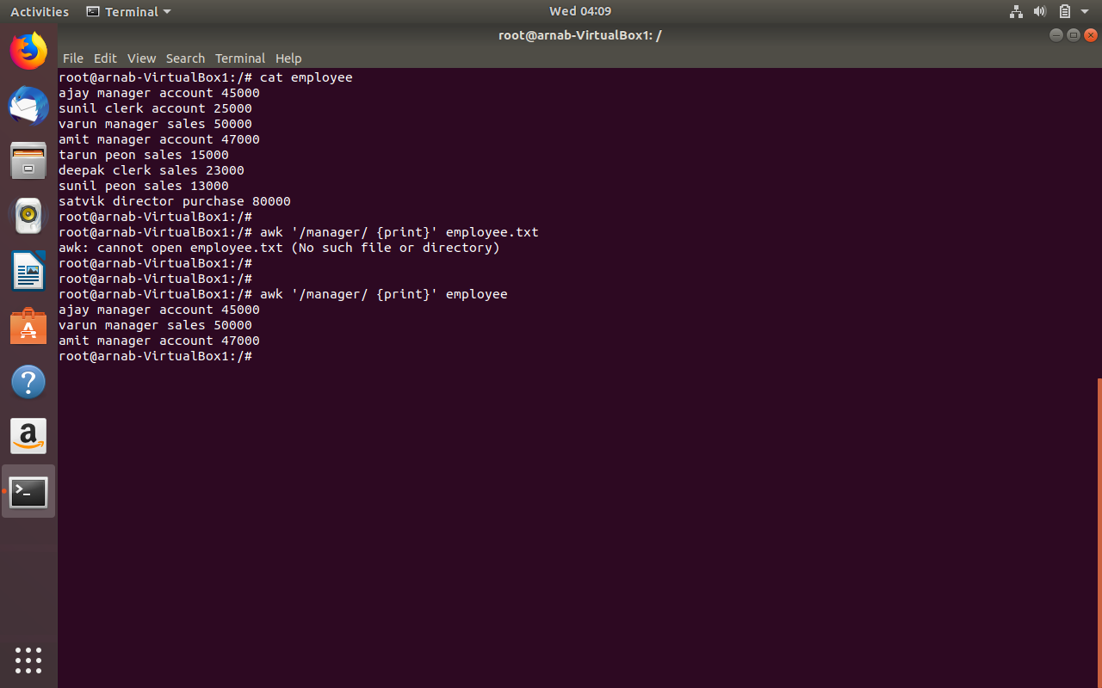

qq. diff : diff command is used for determining the difference between 2 files.

rr. sort : sort command just sorts the content of any file.

ss. export : this is used exporting some shell variable so that it becomes available in subsequent child shell.

tt. pwd : shows present working directory.

uu. crontab: The **crontab** is a list of commands that you want to run on a regular schedule, and also the name of the command used to manage that list. Crontab stands for “cron table, ” because it uses the job scheduler *cron* to execute tasks. Below is an example of crontab for zfs snapshot.

x@X-10-53-67-55-A-VM:~$

x@X-10-53-67-55-A-VM:~$ sudo cat /var/spool/cron/root

*/3 * * * * /usr/sbin/zfs-auto-snapshot --quiet --syslog --label=hourly --prefix=afs-auto-snap --keep=1 --interval=1 //

0 0 * * * /usr/sbin/zfs-auto-snapshot --quiet --syslog --label=daily --prefix=afs-auto-snap --keep=0 --interval=1 //

0 0 * * Sun /usr/sbin/zfs-auto-snapshot --quiet --syslog --label=weekly --prefix=afs-auto-snap --keep=0 --interval=1 //

0 0 1 * * /usr/sbin/zfs-auto-snapshot --quiet --syslog --label=monthly --prefix=afs-auto-snap --keep=0 --interval=1 //

x@X-10-53-67-55-A-VM:~$

vv. mount : This command is used mount a filesystem on linux box. For a NFS share hosted on any fileserver

mount command would be :

mount -t nfs -v 'file-server.example.com:/nfs_share1' '/mnt/share_mount' -o vers=4.

We can also attach a raw disk with the ubuntu vm that we have configured and format it with

fdisk command and create an ext4 filesystem and then mount on the vm with mount command.

ww. passwd : this is used to change the password of any existing user in Linux. Syntax would be

passwd <username>. It will ask for the current password if you are changing the password for the user

that you are logged in with . if you do the same operation from root account the system will not ask for

any older password.

xx. uname : This command is used for querying for Linux kernel version, processor type etc. syntax is

uname -a for all the info related to kernel version patch etc. uname -p for the processor architecture.

yy. whereis : This command is used for locating any command binary file in the filesystem. We can use

whereis bash or whereis ls.

﻿root@arnab-VirtualBox1:/# whereis bash

bash: /bin/bash /etc/bash.bashrc /usr/share/man/man1/bash.1.gz

root@arnab-VirtualBox1:/#

root@arnab-VirtualBox1:/# whereis ls

ls: /bin/ls /usr/share/man/man1/ls.1.gz

root@arnab-VirtualBox1:/#

﻿

Zz: whatis : This command is used to find out what a particular binary is or responsible for.

root@arnab-VirtualBox1:/# whatis bash

bash (1) - GNU Bourne-Again SHell

root@arnab-VirtualBox1:/#

root@arnab-VirtualBox1:/#

root@arnab-VirtualBox1:/# whatis ls

ls (1) - list directory contents

root@arnab-VirtualBox1:/#

aaa. Less : this command is just like more only reverse . generally used for reading file or log file.

Syntax is less filename. more efficient than the “more” command because it does not read the entire file

At one go.

Bbb.su : Used for switching user, such as su <username> or su root.

ccc. ping : To find out whether a remote machine is able to communicate with the local machine at least

with ICMP protocol.

Ddd. Traceroute: it to find out how a packet from the local machine is routed to the remote machine.

With this command we can find out how may hops are required to reach a certain web address.

﻿root@arnab-VirtualBox1:/#

root@arnab-VirtualBox1:/# traceroute google.com

traceroute to google.com (172.217.163.206), 64 hops max

1 192.168.1.1 1.160ms 1.261ms 0.930ms

2 122.172.64.1 5.579ms 203.145.187.185 7.307ms 4.827ms

3 202.56.198.129 6.216ms 182.79.224.134 25.431ms 23.915ms

4 182.79.142.121 23.059ms 72.14.220.197 31.225ms 31.166ms

5 72.14.220.197 36.440ms * *

6 * * 74.125.251.132 34.832ms

7 72.14.220.197 34.170ms * *

8 * 108.170.235.50 33.641ms 32.760ms

9 108.170.235.50 31.550ms 108.170.248.218 30.140ms 30.319ms

10 216.239.50.171 30.925ms 74.125.242.145 30.968ms 30.918ms

11 74.125.242.129 44.554ms 209.85.248.219 37.141ms 33.736ms

12 209.85.248.219 31.231ms 172.217.163.206 30.540ms 29.752ms

root@arnab-VirtualBox1:/#

eee. Date: To find out the current date in the system.

Fff. Time : covered earlier , this is repetition.

ggg. Wget : this command is sued to download some file from internet or some web-address. Generally

used to download builds or log files to the local machine.

Syntax is wget <site addredd|remote_machine:/path/to/some/file>. If directory use wget -r

hhh. W: w displays information about the users currently on the machine, and their processes. The header shows, in this order, the current time, how long the system has been running, how many users are currently

logged on, and the system load averages for the past 1, 5, and 15 minutes.

﻿root@arnab-VirtualBox1:/# w -h

arnab :0 :0 01:03 ?xdm? 1:37 0.00s /usr/lib/gdm3/gdm-x-session --run-script env GNOME_SHELL_SESSION_MOD

root@arnab-VirtualBox1:/#

iii. clear : it clears the screen of the machine .

jjj. exit : exit command is used to end a process which is executing with exit code. We can also use exit

on the Linux console or bash prompt to end session. Exit can also be used in shell script to communicate

an exit status to the calling program.

8)Turn on Firewall and block all ports

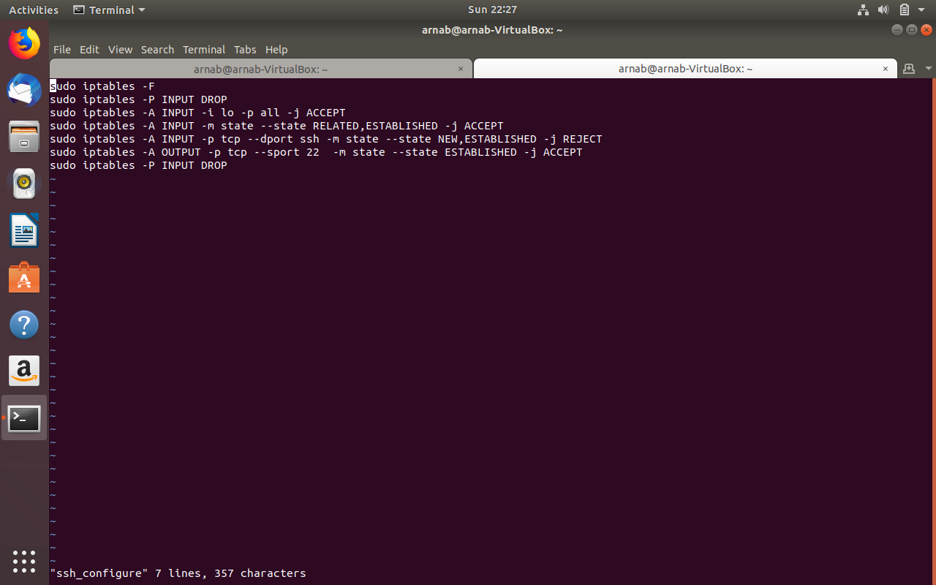

9. Enable SSH access to your new Linux installation; open SSH port in firewall

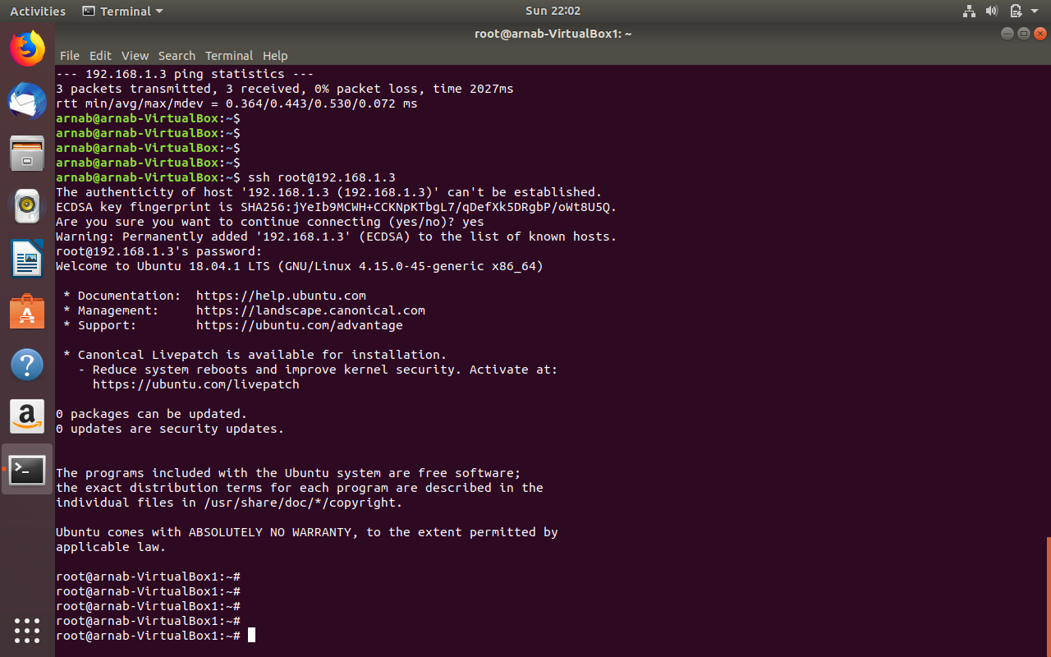

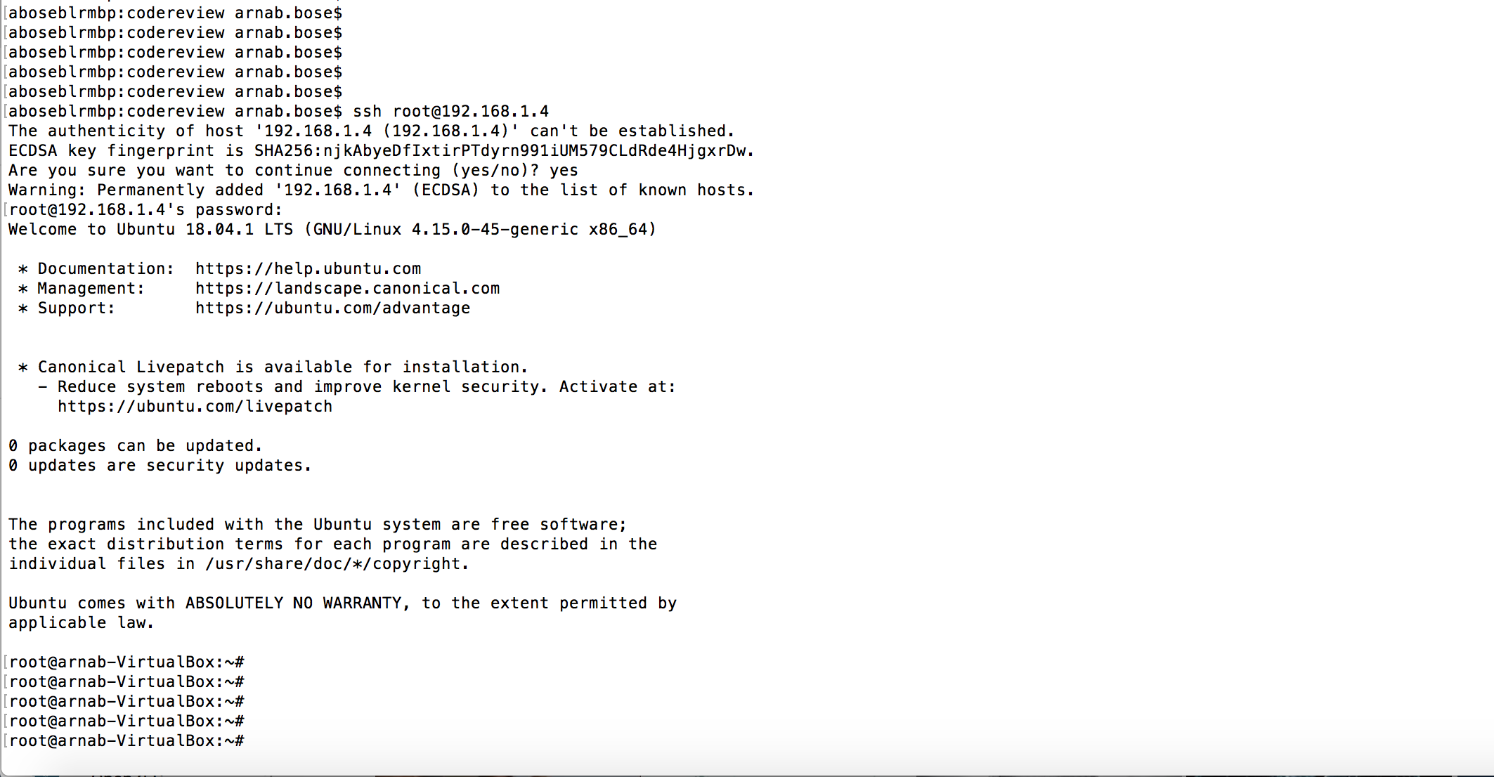

Installation screenshots:

